KALINGA INSTITUTE OF INDUSTRIAL TECHNOLOGY
School of Computer Engineering
SAP ERP Curriculum — Project Submission

SAP ERP BLUEPRINT DOCUMENT
Enterprise Structure Design & Customization
for
NovaTrade Industries Pvt. Ltd.

Modules Covered | FI · MM · SD | Academic Year | 2024–25
Submitted To | SAP Faculty — KIIT University | Course | SAP ERP Fundamentals

Prepared by Student — KIIT University, Bhubaneswar
April 2025

1. Executive Summary

This document presents a comprehensive SAP ERP blueprint for NovaTrade Industries Pvt. Ltd., a fictitious mid-size Indian trading and light manufacturing enterprise headquartered in New Delhi. The blueprint covers the design, enterprise structure definition, and customization steps for three core SAP functional modules: Financial Accounting (FI), Materials Management (MM), and Sales & Distribution (SD).
The objective of this project is to simulate a real-world SAP implementation engagement — from initial company definition and organizational structure setup through master data configuration and cross-module integration mapping. The document follows the standard SAP implementation methodology (ASAP/Activate) and mirrors the artifacts a functional consultant would produce during the Blueprint phase of an SAP project.

2. Company Profile — NovaTrade Industries Pvt. Ltd.

NovaTrade Industries Pvt. Ltd. is a fictitious company incorporated under the Companies Act, 2013. It operates in two primary business verticals: consumer electronics distribution and fast-moving consumer goods (FMCG) manufacturing. The company has a centralized head office in New Delhi and a manufacturing plant in Noida, Uttar Pradesh.

Company Attribute | Details
Company Name | NovaTrade Industries Pvt. Ltd.
Company Code | NT01
Country | India
Currency | INR (Indian Rupee)
Industry Sector | Consumer Electronics & FMCG
Fiscal Year | April 1 — March 31 (Indian Financial Year)
Language | EN (English)
Chart of Accounts | NTIN (NovaTrade India)
SAP Client | 100
Head Office | Connaught Place, New Delhi — 110001
Manufacturing Plant | Sector 63, Noida, Uttar Pradesh — 201301
Annual Turnover (Fictitious) | INR 850 Crores
Number of Employees | Approx. 1,200

2.1 Business Operations Overview
NovaTrade operates across two divisions:
- Electronics Division: Imports consumer electronics (smartphones, laptops, accessories) and distributes them through a network of authorized dealers and retail partners across North India.
- FMCG Division: Manufactures and distributes packaged food products and personal care items through wholesale and retail channels nationwide.

3. SAP Enterprise Structure

The SAP enterprise structure defines the organizational units within the system and how they relate to each other. These units mirror the real-world legal, financial, and operational divisions of NovaTrade Industries. The structure is defined at the highest level with a SAP Client, followed by the Company Code, and then module-specific sub-units.

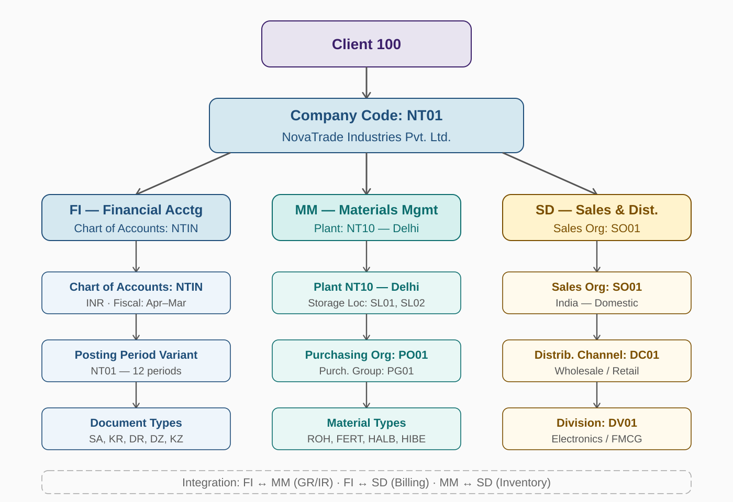
Figure 1: SAP Enterprise Structure — NovaTrade Industries Pvt. Ltd. (Client 100)

3.1 Financial Accounting (FI) Structure
FI Org Unit | ID / Value | Description
Company Code | NT01 | Legal entity — NovaTrade Industries Pvt. Ltd.
Chart of Accounts | NTIN | NovaTrade India custom CoA linked to NT01
Fiscal Year Variant | V3 | April to March, 12 posting periods + 4 special
Posting Period Variant | NT01 | Controls open/closed periods for NT01
Field Status Variant | NT01 | Defines mandatory/optional fields per GL account
Currency | INR | Indian Rupee as company code currency
Credit Control Area | NT01 | Customer credit monitoring for NT01

3.2 Materials Management (MM) Structure
MM Org Unit | ID / Value | Description
Plant | NT10 | New Delhi — Distribution Hub (Head Office)
Plant | NT20 | Noida — Manufacturing Plant
Storage Location | SL01 | Raw Material Store (NT20)
Storage Location | SL02 | Finished Goods Warehouse (NT10)
Storage Location | SL03 | Spare Parts & Consumables Store (NT10)
Purchasing Organization | PO01 | Central Purchasing — all vendors for NT01
Purchasing Group | PG01 | Electronics Procurement Team
Purchasing Group | PG02 | FMCG Raw Material Procurement Team
Valuation Area | NT10 / NT20 | Plant-level valuation (Moving Average Price)

3.3 Sales & Distribution (SD) Structure
SD Org Unit | ID / Value | Description
Sales Organization | SO01 | India Domestic Sales — NovaTrade
Distribution Channel | DC01 | Wholesale — B2B channel to dealers
Distribution Channel | DC02 | Retail — Direct-to-consumer / e-commerce
Division | DV01 | Electronics Division
Division | DV02 | FMCG Division
Sales Area | SO01/DC01/DV01 | Electronics — Wholesale
Sales Area | SO01/DC02/DV02 | FMCG — Retail
Shipping Point | SP01 | New Delhi Dispatch Hub
Sales District | SD-NORTH | North India Territory

4. Master Data Configuration

Master data forms the foundation of all transactional processing in SAP. The following master data objects are defined for NovaTrade Industries. Unlike configuration (which is done once), master data is maintained on an ongoing basis by business users.

4.1 GL Account Master Data (FI)
The General Ledger (GL) accounts are organized under the chart of accounts NTIN. The key account groups and sample accounts are listed below:
Account Group | Account Range | Sample Accounts
Balance Sheet — Assets | 100000–199999 | Cash, Bank SBI, Accounts Receivable, Fixed Assets
Balance Sheet — Liabilities | 200000–299999 | Accounts Payable, Loans, GST Payable
Revenue Accounts | 300000–399999 | Domestic Sales, Export Sales, Service Revenue
Cost of Goods Sold | 400000–499999 | COGS Electronics, COGS FMCG, Freight Outward
Operating Expenses | 500000–599999 | Salaries, Rent, Utilities, Marketing Expenses
Tax Accounts | 600000–699999 | Input GST, Output GST, TDS Payable, Advance Tax

4.2 Vendor Master Data (MM/FI)
Vendor master records are created centrally and include both purchasing data (used in MM) and accounting data (used in FI). Key vendors for NovaTrade:
Vendor ID | Vendor Name | Category | Payment Terms
V1001 | Samsung India Electronics Pvt. Ltd. | Electronics Supplier | Net 30 days
V1002 | Hindustan Unilever Ltd. | FMCG Raw Materials | Net 45 days
V1003 | Blue Dart Logistics Pvt. Ltd. | Freight / 3PL | Net 15 days
V1004 | Tata Packaging Solutions | Packaging Materials | Net 30 days

4.3 Customer Master Data (SD/FI)
Customer ID | Customer Name | Channel | Credit Limit
C2001 | Croma Retail Ltd. | Retail (DC02) | INR 2,00,00,000
C2002 | Metro Cash & Carry India | Wholesale (DC01) | INR 5,00,00,000
C2003 | Reliance Digital Pvt. Ltd. | Retail (DC02) | INR 3,50,00,000
C2004 | Amazon Seller Services Pvt. Ltd. | Retail (DC02) | INR 10,00,00,000

4.4 Material Master Data (MM)
The material master is the central repository for all material-related data. NovaTrade uses the following material types:
Material Type | Code | Example Materials | Valuation
Raw Material | ROH | Packaging film, Glass jars, Aluminium foil | Moving Avg. Price
Finished Goods | FERT | iPhone 15, Samsung S24, Packaged Biscuits | Standard Price
Semi-finished | HALB | Assembled PCB, Mixed food base | Moving Avg. Price
Trading Goods | HAWA | Mobile accessories, Cables, Adapters | Moving Avg. Price
Non-valuated Material | NLAG | Office stationery, Cleaning supplies | Non-valuated

5. Customization Steps (SPRO / IMG)

All SAP configuration is performed via the Implementation Guide (IMG), accessed through Transaction SPRO. The following sub-sections document the key customization steps for each module. Steps are listed in the sequence they must be performed, as later steps depend on earlier ones.

5.1 FI — Financial Accounting Customization
Path in SPRO: Financial Accounting > Financial Accounting Global Settings > Company Code > Enter Global Parameters

Step 1: Define Company and Company Code
- Transaction: OX15 — Define Company
- Transaction: OX02 — Create Company Code NT01
- Assign company code currency: INR
- Set language: EN
- Assign company code to company using T-code OX16

Step 2: Define Chart of Accounts
- Transaction: OB13 — Create Chart of Accounts NTIN
- Set account length: 6 digits
- Set controlling integration: assign NTIN to company code NT01 (OB62)
- Define account groups (OBD4): Assets, Liabilities, Revenue, Expenses, Tax
- Define retained earnings account: 290000

Step 3: Define Fiscal Year Variant
- Transaction: OB29 — Create Fiscal Year Variant V3
- Set 12 normal periods (April to March) + 4 special periods
- Assign fiscal year variant to company code NT01 (OB37)

Step 4: Define Posting Period Variant
- Transaction: OBBO — Create Posting Period Variant NT01
- Open periods 1–12 for current year
- Assign posting period variant to company code (OBBP)

Step 5: Define Document Types & Number Ranges
- Transaction: OBA7 — Define document types
- Key document types: SA (GL), KR (Vendor Invoice), KZ (Vendor Payment), DR (Customer Invoice), DZ (Customer Payment)
- Transaction: FBN1 — Define number ranges per document type per company code

Step 6: Define Tolerance Groups
- Transaction: OBA4 — Tolerance groups for employees (permitted payment differences)
- Transaction: OBA3 — Tolerance groups for customers/vendors

Step 7: Configure Taxes (GST)
- Transaction: FTXP — Define tax codes for India GST
- Define tax codes: I1 (Input GST 18%), O1 (Output GST 18%), I0 (Input GST 0%), O0 (Output GST 0%)
- Assign tax accounts to GL accounts 600010 (Input GST), 600020 (Output GST)

5.2 MM — Materials Management Customization
Path in SPRO: Materials Management > Purchasing / Inventory Management > Define Organizational Units

Step 1: Define Plants
- Transaction: OX10 — Create Plant NT10 (New Delhi Hub)
- Transaction: OX10 — Create Plant NT20 (Noida Manufacturing)
- Set country, language, time zone, factory calendar for each plant
- Assign plants to company code NT01 (OX18)

Step 2: Define Storage Locations
- Transaction: OX09 — Create SL01 (Raw Material Store) under NT20
- Transaction: OX09 — Create SL02 (Finished Goods Warehouse) under NT10
- Transaction: OX09 — Create SL03 (Spare Parts) under NT10

Step 3: Define Purchasing Organization
- Transaction: OX08 — Create Purchasing Org PO01 (NovaTrade Central Purchasing)
- Assign Purchasing Org to company code (OX01)
- Assign Purchasing Org to plants NT10, NT20 (OX17)
- Define Purchasing Groups PG01 (Electronics), PG02 (FMCG) via OME4

Step 4: Define Material Types
- Transaction: OMS2 — Review and configure standard material types (ROH, FERT, HALB, HAWA, NLAG)
- Set quantity/value updating for each material type per plant
- Assign number ranges to material types (MMNR)

Step 5: Configure Valuation & Account Determination
- Transaction: OMWM — Set valuation level to Plant
- Transaction: OMSK — Define valuation class for each material type
- Transaction: OBYC — Configure automatic account determination (GBB, BSX, WRX keys)
- Key movement types: 101 (GR), 102 (GR Reversal), 261 (Goods Issue to Production), 601 (Delivery PGI)

Step 6: Configure Purchase Order Document Types
- Transaction: OMH6 — Define PO document types: NB (Standard), FO (Framework Order)
- Define number ranges for POs (OMH7)
- Define release (approval) strategy for POs above INR 5,00,000 (ME29N)

5.3 SD — Sales & Distribution Customization
Path in SPRO: Sales and Distribution > Sales > Sales Documents > Define Sales Document Types

Step 1: Define Sales Organization
- Transaction: OVX5 — Create Sales Organization SO01 (NovaTrade India Sales)
- Assign Sales Organization to Company Code NT01 (OVX3)

Step 2: Define Distribution Channels & Divisions
- Transaction: OVXI — Create Distribution Channel DC01 (Wholesale), DC02 (Retail)
- Transaction: OVXB — Create Divisions DV01 (Electronics), DV02 (FMCG)
- Assign distribution channels and divisions to Sales Org SO01 (OVXK, OVXA)
- Define Sales Areas: SO01/DC01/DV01, SO01/DC02/DV02 (OVXG)

Step 3: Define Sales Document Types
- Standard Order: OR — used for normal B2B and B2C orders
- Rush Order: RO — for same-day delivery requirement
- Returns: RE — for customer return processing
- Credit Memo Request: CR, Debit Memo Request: DR
- Configure number ranges for each document type

Step 4: Configure Pricing Procedure
- Transaction: V/08 — Define pricing procedure NTPRC (NovaTrade Pricing)
- Condition types: PR00 (Base Price), K007 (Customer Discount %), MWST (Output Tax), SKTO (Cash Discount)
- Assign pricing procedure to sales area + customer pricing procedure combination

Step 5: Configure Shipping and Delivery
- Transaction: OVLK — Define delivery types: LF (Outbound Delivery), LR (Returns Delivery)
- Define Shipping Point SP01 (New Delhi) and assign to plant NT10
- Define routes: standard road route RT01 for North India zone

Step 6: Configure Billing
- Transaction: VOFA — Define billing type F2 (Standard Invoice), RE (Credit Memo)
- Assign billing type to delivery type
- Configure revenue account determination (VKOA) — link sales to GL account 300010

6. End-to-End Process Flows

6.1 Procure-to-Pay (P2P) Process — SAP MM
The Procure-to-Pay cycle covers the entire process from identifying a procurement need to making payment to the vendor. The following diagram illustrates the 6-step P2P cycle as configured in NovaTrade's SAP system:

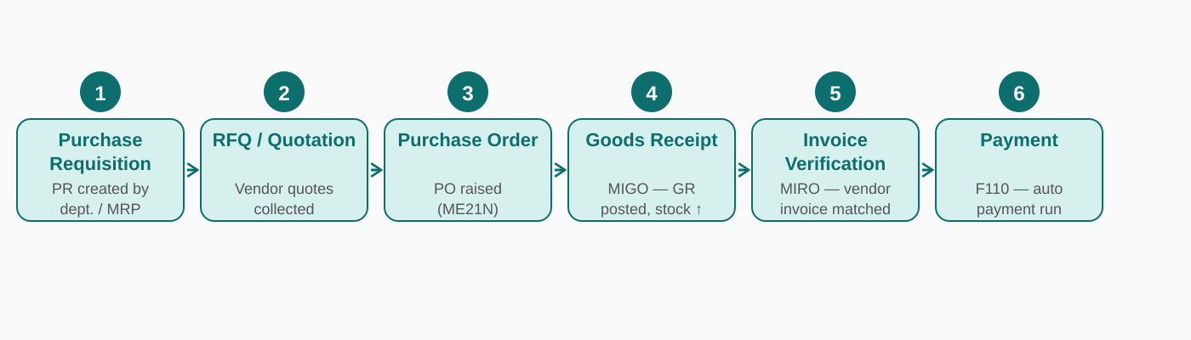
Figure 2: Procure-to-Pay (P2P) Process Flow — NovaTrade Industries (SAP MM)

Step | Process | T-Code | Description
1 | Purchase Requisition | ME51N | Dept. raises PR or MRP auto-generates requirement
2 | RFQ & Quotation | ME41 / ME47 | Request For Quotation sent to vendors; quotations compared via ME49
3 | Purchase Order | ME21N | PO raised after price comparison; approval via release strategy
4 | Goods Receipt | MIGO (101) | Warehouse records receipt; stock increases; GR/IR account posted
5 | Invoice Verification | MIRO | Vendor invoice matched to PO and GR (3-way match); any variances flagged
6 | Payment to Vendor | F110 | Automatic payment run processes due invoices per payment terms

6.2 Order-to-Cash (O2C) Process — SAP SD
The Order-to-Cash cycle captures the complete sales lifecycle from customer inquiry through to cash receipt. NovaTrade follows a 7-step O2C process:

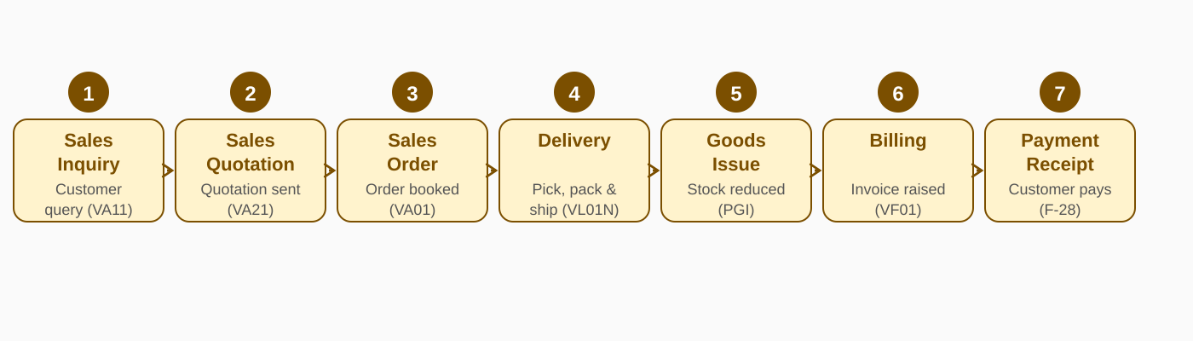
Figure 3: Order-to-Cash (O2C) Process Flow — NovaTrade Industries (SAP SD)

Step | Process | T-Code | Description
1 | Sales Inquiry | VA11 | Customer raises product inquiry; captured in system
2 | Sales Quotation | VA21 | Formal quotation with pricing sent to customer; valid for 30 days
3 | Sales Order | VA01 | Customer confirms; sales order booked with delivery date and pricing
4 | Outbound Delivery | VL01N | Delivery document created; picking and packing of goods initiated
5 | Goods Issue (PGI) | VL02N | Post Goods Issue reduces inventory; COGS entry in FI
6 | Billing / Invoice | VF01 | Customer invoice generated; FI document posted to Accounts Receivable
7 | Payment Receipt | F-28 | Customer payment cleared against open AR item; bank account updated

7. Cross-Module Integration (FI-MM-SD)

One of the most powerful aspects of SAP ERP is its real-time, automatic integration between modules. In NovaTrade's setup, every business transaction in MM or SD automatically generates corresponding accounting entries in FI without manual intervention. This ensures the general ledger is always up to date and audit-ready.

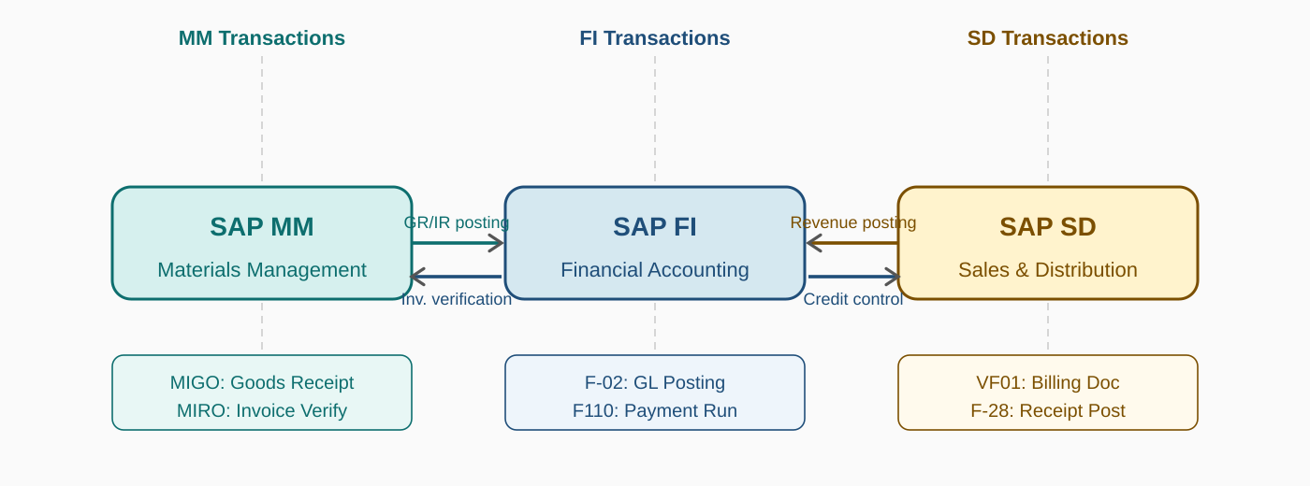
Figure 4: FI-MM-SD Cross-Module Integration — Automatic Document Flow

7.1 FI-MM Integration
MM Event | FI Automatic Posting | GL Accounts Affected
Goods Receipt (MIGO 101) | Dr. Inventory A/c / Cr. GR/IR Clearing | 150010 (Inventory) / 200060 (GR/IR)
Invoice Verification (MIRO) | Dr. GR/IR Clearing / Cr. Vendor Payable | 200060 (GR/IR) / 200010 (AP-Vendor)
Vendor Payment (F110) | Dr. Vendor Payable / Cr. Bank Account | 200010 (AP) / 100020 (Bank SBI)
Goods Issue to Production (261) | Dr. COGS / Cr. Inventory | 400010 (COGS) / 150010 (Inventory)

7.2 FI-SD Integration
SD Event | FI Automatic Posting | GL Accounts Affected
Post Goods Issue (VL02N-PGI) | Dr. COGS / Cr. Finished Goods Inventory | 400010 (COGS) / 150020 (FG Inventory)
Billing Document (VF01) | Dr. Accounts Receivable / Cr. Sales Revenue | 100030 (AR-Customer) / 300010 (Revenue)
Output Tax on Billing | Dr. Customer / Cr. Output GST | 100030 (AR) / 600020 (Output GST)
Customer Payment (F-28) | Dr. Bank / Cr. Accounts Receivable | 100020 (Bank) / 100030 (AR)

8. Key SAP Reports & Analytics

SAP provides a rich set of standard reports that NovaTrade's management and finance teams will use on a daily, monthly, and annual basis. The following are the most critical reports configured for each module:

Module | Report Name | T-Code | Purpose
FI | General Ledger Report | S_ALR_87012291 | Trial balance & GL line items
FI | Accounts Payable Aging | S_ALR_87012085 | Vendor dues by aging bucket
FI | Accounts Receivable Aging | S_ALR_87012168 | Customer outstanding analysis
FI | Financial Statements | S_ALR_87012284 | P&L and Balance Sheet
MM | Stock Overview | MMBE | Current stock by plant/SLoc
MM | Purchase Order Report | ME2M / ME2N | PO tracking by material/vendor
MM | GR/IR Clearing Report | MB5S | Uncleared GR/IR analysis
SD | Sales Order Report | VA05 | Open/completed sales orders
SD | Billing Document Report | VF05 | Invoice listing by period
SD | Customer Sales Analysis | S_ALR_87012186 | Revenue by customer/product

9. Conclusion

This SAP ERP Blueprint document has comprehensively outlined the enterprise structure, master data definition, customization steps, and end-to-end process flows for NovaTrade Industries Pvt. Ltd. across the three core modules — Financial Accounting (FI), Materials Management (MM), and Sales & Distribution (SD).
The blueprint demonstrates how a mid-size Indian enterprise with dual business divisions (Electronics and FMCG) can leverage SAP's highly integrated architecture to achieve real-time financial visibility, streamlined procurement, and efficient order fulfillment. Key highlights of this design include:
- A centrally managed chart of accounts (NTIN) aligned with Indian fiscal regulations and GST requirements.
- A two-plant structure (Delhi Hub and Noida Plant) optimized for distribution and manufacturing operations respectively.
- Dual distribution channels enabling both B2B wholesale and B2C retail business models within the same SAP system.
- Automatic cross-module integration ensuring every goods movement and billing event instantly updates the general ledger without manual journal entries.
- A structured purchasing approval workflow with a release strategy for high-value purchase orders.

The implementation of this blueprint would result in a unified, real-time ERP system enabling NovaTrade's management to access accurate financial reports, track inventory levels, monitor customer receivables, and manage vendor payables — all within a single integrated platform. This document serves as the foundational reference for the technical configuration team to proceed with the Realization phase of the SAP project.

10. Appendix — Transaction Code Reference

T-Code | Description | Module | Phase
SPRO | SAP Project Reference Object (IMG) | All | Configuration
OX02 | Create Company Code | FI | Configuration
OB13 | Create Chart of Accounts | FI | Configuration
OB29 | Define Fiscal Year Variant | FI | Configuration
OX10 | Define Plant | MM | Configuration
OX08 | Define Purchasing Organization | MM | Configuration
OMWM | Set Valuation Level | MM | Configuration
OVX5 | Define Sales Organization | SD | Configuration
V/08 | Define Pricing Procedure | SD | Configuration
ME51N | Create Purchase Requisition | MM | Transaction
ME21N | Create Purchase Order | MM | Transaction
MIGO | Goods Movement (GR/GI/Transfer) | MM | Transaction
MIRO | Logistics Invoice Verification | MM/FI | Transaction
F110 | Automatic Payment Run | FI | Transaction
VA01 | Create Sales Order | SD | Transaction
VL01N | Create Outbound Delivery | SD | Transaction
VF01 | Create Billing Document | SD | Transaction
F-28 | Post Incoming Payment | FI | Transaction

— End of Document —
NovaTrade Industries Pvt. Ltd. | SAP ERP Blueprint | KIIT University | 2025

